**Run in background**

In starter folder 🡪 live-server

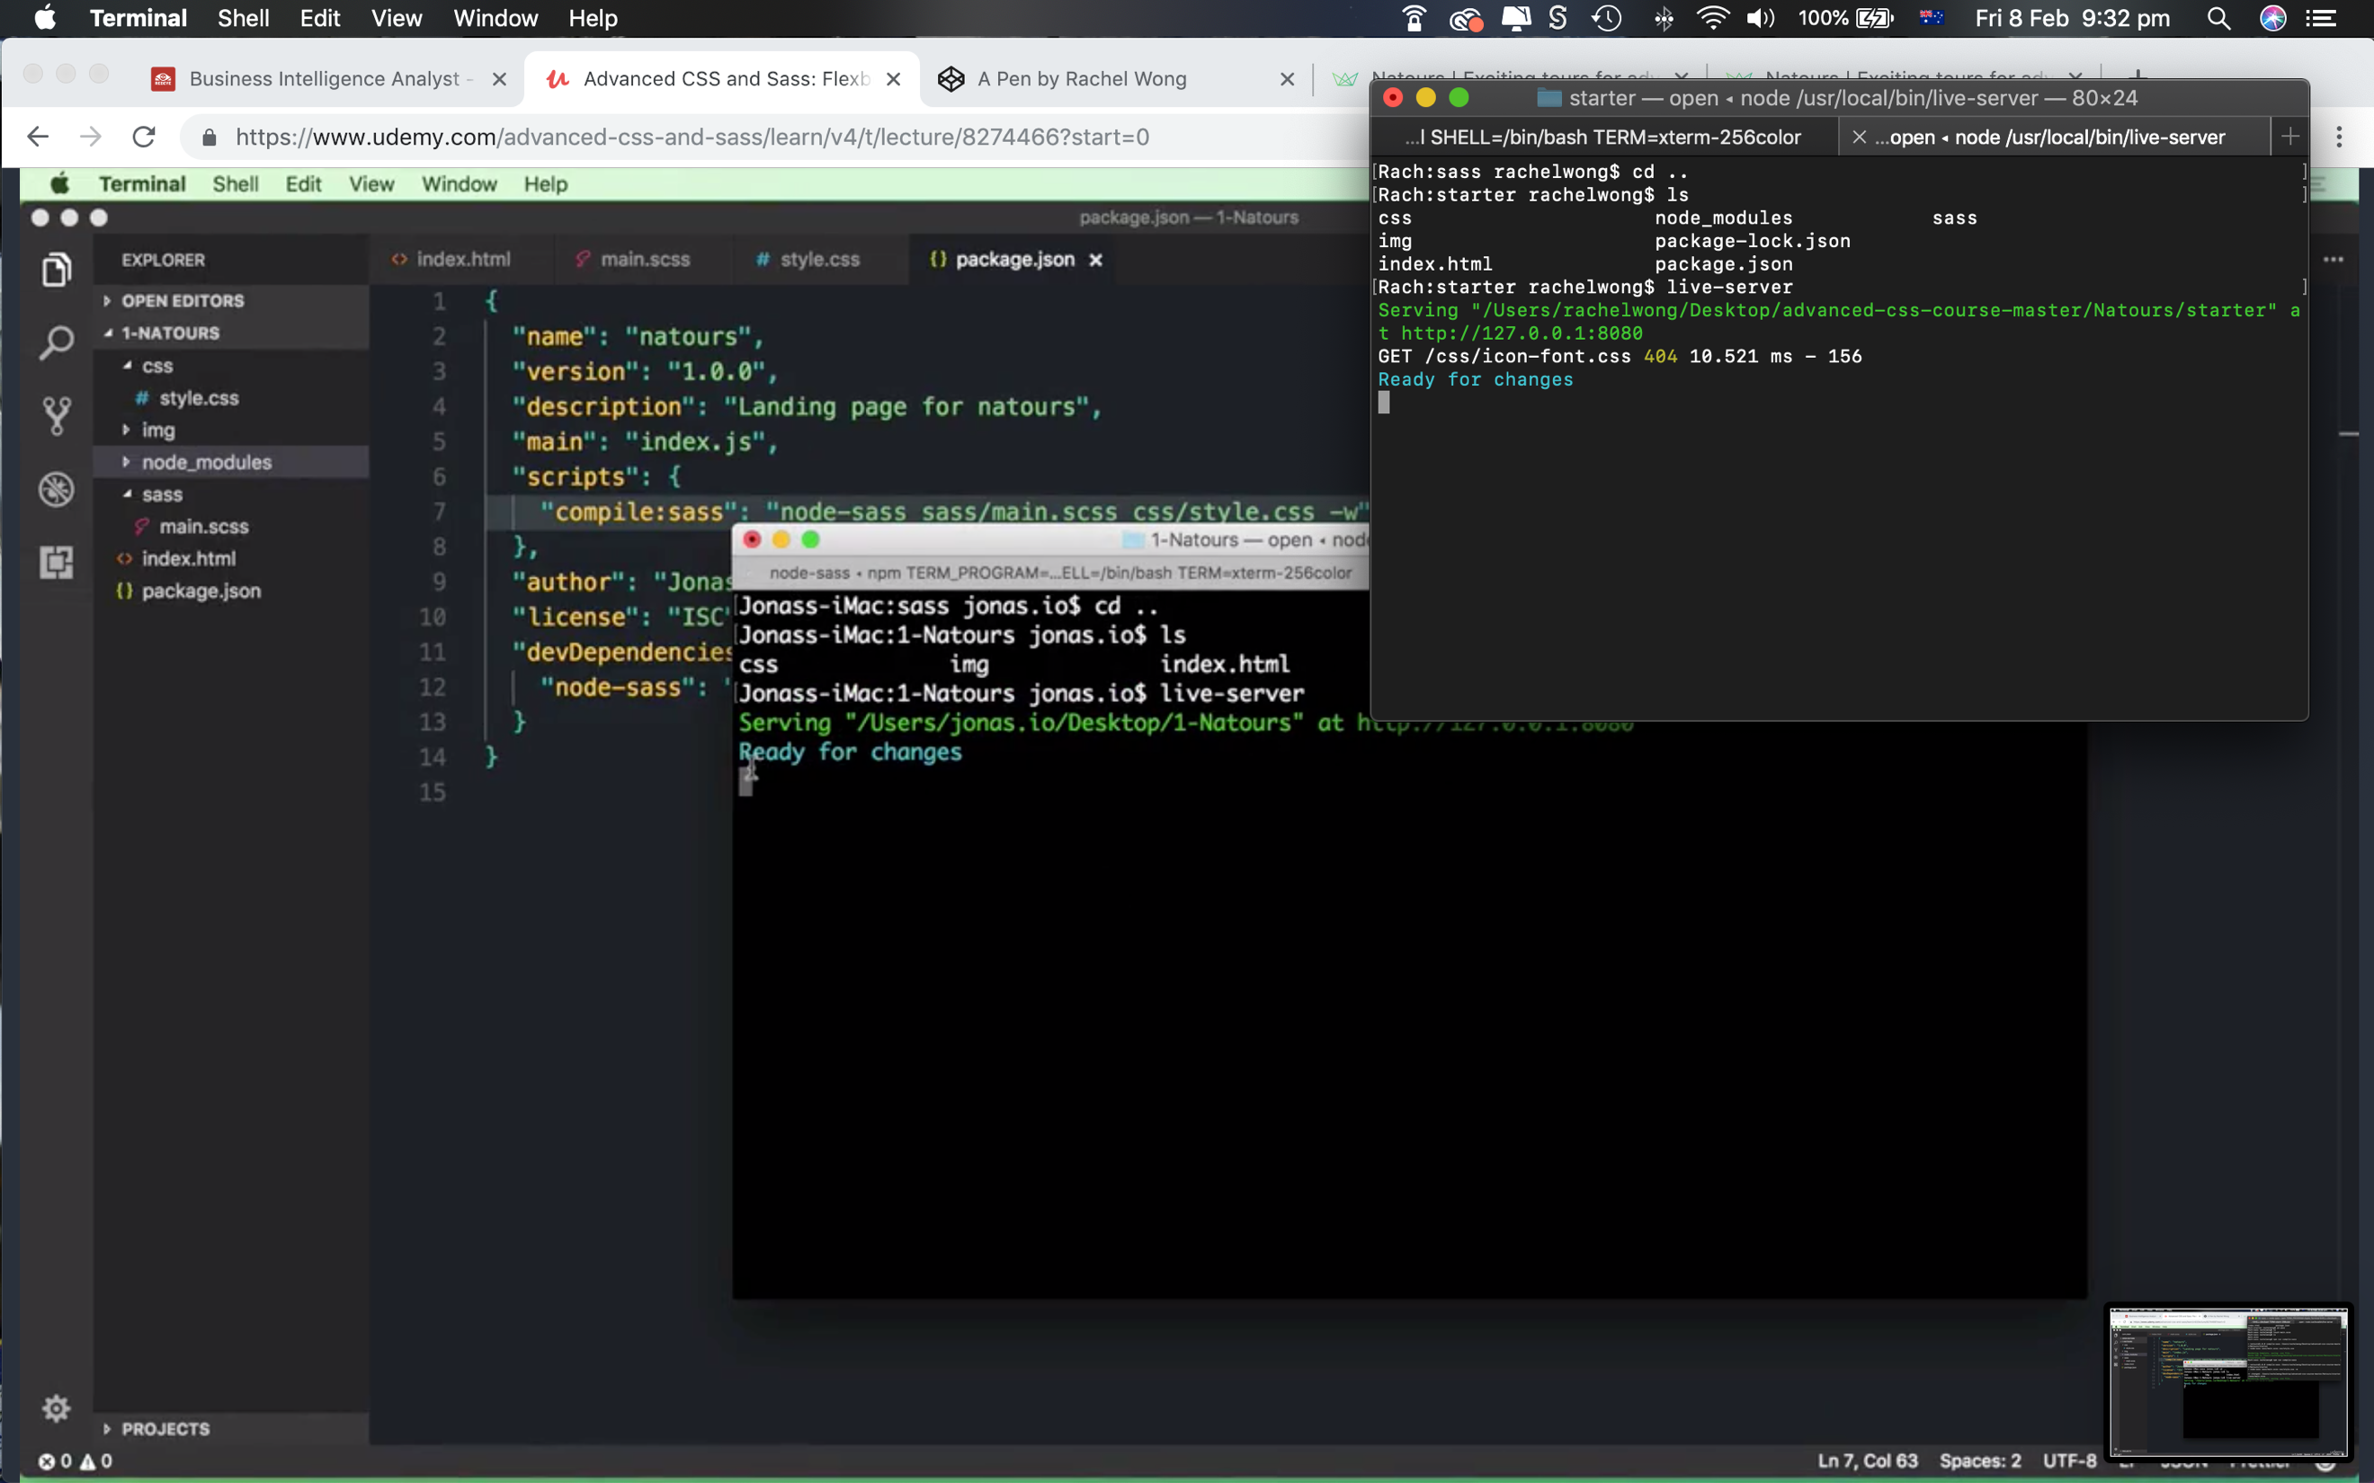

In sass folder 🡪 npm run compile:sass

